CHAPTER ONE
INTRODUCTION
1.1 Background of Study
Shoes are part of the essence of human life, moving beyond the functions of ease and defense to become part of fashion, social signaling, and workplace identity. Among the numerous types of shoes, the leather formal shoe holds a specific status, particularly in the workplace and official settings. Their appearance and durability require constant and periodic maintenance, one of the simplest components of which is shoe polishing.
Polishing shoes has two effects: it enhances the appearance of the shoe to make it shiny and sophisticated, and it keeps the leather safe from the external elements such as water, dust, and wear and tear. Polished footwear not only indicates good self-grooming, but it also speaks volumes of one's professionalism and attention to detail, which are mostly appreciated in any professional environment.
Historically, polishing shoes has been achieved through manual methods using organic compounds. Before the early part of the 20th century, wax, ash, and tallow mixtures would be rubbed into the leather surface using cloths or brushes[1]. Though effective, the methods consumed time and labor. Moreover, the finish quality varied depending upon the skill of the individual doing the work and the ease of the materials at hand.
The early part of the 20th century witnessed the advent of the modern shoe care era with the introduction of liquid and solid polishes. These polishes, typically composed of waxes, solvents, and colorants, carried out the polishing process more smoothly and left an improved finish. Still, the process of applying the same remained manual, and efficiency and capacity remained limited.
The advancements of technology in automation have led to the use of robotic systems in many areas of life, including the care of shoes. Automatic shoe polishers are an easy yet efficient means of keeping shoes polished and clean to individuals who want to do so with minimal work involved. Automatic shoe polishers normally involve the use of rotating rollers, supplemented by liquid dispensers, to polish the shoes without rubbing, to polish manually
Though becoming more popular, current automatic shoe polishing machines are plagued with several negative aspects that prevent large-scale use. They are not flexible enough to be capable of adapting to various shoe sizes and shapes, the amount of polish applied is not uniform, ending up with unbalanced finishes, and no mechanisms to clean the grime and trash prior to polishing are integrated. These traits demonstrate the necessity of innovative design which can solve such issues to enhance the performance potential, along with user ease, of automatic shoe polishing machines [2].
Research has been focused lately toward integrating cooperative robot systems into shoe polishing, attempting to harness the power of automation combined with the human operator's craftsmanship. These systems are aimed at the combination of automatic systems' efficiency and consistency with human operators' dexterity and flexibility to produce high-quality finishes using the least possible manual labor. For example, [3] discusses the design of human-oriented robot systems that combine the power of automation with the human operator's craftsmanship, attempting to realize the least possible manual labor along with a high-quality finish. Similarly, research work by [4] considers cooperative human-robot approach to be adopted to be applied to high-quality leather shoes, with the aspect of retaining the process quality through automation. These works refer to the potential of cooperative systems to mitigate the disadvantages of traditional automatic polishing of shoes.
This background study is focused on developing and designing an automatic shoe polishing machine for Lagos State University (LASU), Epe Campus. This project is being proposed to address the lack of an easy, hygienic, and efficient means of keeping widely used cover shoes by students and working staff in their best condition thus bridging the gap between existing technologies and the evolving needs of consumers, and offer an appropriate replacement for traditional methods of polishing shoes.
1.2 Problem Statement
Highly polished shoes are essentials at workplace and school environment like Lagos State University to maintain a neat and respectful image, conveying competency along with neatness, except that traditional polishing is time consuming, painstaking, and tends to deliver inconsistent results. Most professionals, due to stringent deadlines, or physical restrictions, are unable to maintain footwear regularly, resulting not only in loss of appearance, but also longevity. Though some automatic devices are available, these are not complete, with few cleaning or polishing, but not having any versatility to treat varying sizes, nor producing professional-level results. This brings into the scenario the requirement of an efficient, convenient, and user-friendly solution, specifically dedicated to formal leather shoes.
1.3 Aim and Objectives
The aim of this project is to design and develop an Automated Shoe Polishing Machine that efficiently cleans and shines cover shoes using rotating brushes and liquid polish dispenser. It shall be an economical shoe-maintenance device involving minimal labor along with the professional finish.
Objectives of the Project
- To design an automated shoe polishing machine with both cleaning and polishing functionalities
- To develop the integrated hardware and software control system, utilizing an Arduino microcontroller.
- To evaluate the performance of the design through testing.

1.4 Scope of Study
The project scope covers several technical and practical aspects with regard to the design and creation of an automated shoe polishing machine. The project aims at solving issues of manual shoe cleaning, hygiene, efficiency, and practical experience in electromechanical design.
The design principles behind the use of vertical and horizontal rotating brushes to polish and clean formal leather shoes include research into the different brush types, materials, and configurations to find the optimal method of attaining superior polish with the least likelihood of damage to the leather. Under this project, the optimal rotation rates, pressure, and brush inclination to use to properly clean the shoes in addition to the distribution of the polish will be explored.
The project will handle the correct assembly and integration of the mechanical and electrical components into one complete device. This involves careful planning and carrying out the assembly process, observing the correct positioning of all the components, mating the components, and fastening the components properly. The project will handle the problem of vibration, noise, and heat to ensure the reliability and lifespan of the machine.
It will implement and include an integrated microcontroller-based control system that will regulate the operation of the brushes, the dispenser, and the sensors. Timing, rotation rates, and dispensing of the polish will be controlled based on sensor input and user input using the control logic. This involves the design of the software algorithms that will regulate the various components of the system, ensure efficiency, and provide real-time information to the user.

CHAPTER TWO
LITERATURE REVIEW
2.1 Theoretical Background
Polishing shoe has improved immensely, ranging from the ages-old manual application to semi-automatics to fully automatic systems. Traditional manual methods of polishing entailed the use of waxes or oils, which were laborious to use and inconsistent, applied by cloths or brushes. These manual methods needed skill to produce a good, uniform finish, the nature of which depended upon the skill of the person doing the polishing, along with the nature of the materials involved.
The automatic machinery has been designed to improve the polishing finish, conserve time, and reduce labor [5]. Manufacturers, through the use of automation, have attempted to make the process of polishing more efficient, uniform, and labor-minimizing. Mechanical engineering, electrical systems, and controls technology developments have triggered the innovation, which has led to improved, but easier-to-use, equipment.
Early automatic shoe polishers typically consisted of motor-driven brushes, polish dispensers, and housings. They endeavored to simulate the manual polishing process, where the rotating brushes applied and rubbed the polish onto the shoe surface. A paper published by [6] studied an example double rotating brush semi-automatic shoe polish machine and the importance of the rotation rate of the brush and the viscosity of the polish to the operation of the machine. They emphasized user convenience and listed user safety as one of the top priorities.
The movement towards automatic shoe polishing has been fueled by various factors, including saving labor, gaining consistency, and offering greater convenience to the end user. Automatic shoe polishers, thanks to the innovation that has been achieved through technology, now boast sophisticated capabilities such as adjustable brush speed, programmable polish cycles, and onboard cleaning systems.
Also, the theoretical knowledge of shoe polishing has improved with time, and researchers and manufacturers came to realize the details of the chemical and physical processes involved. Studies explored the interaction of different types of polish with the leather, the optimal means of getting an optimal finish, etc. All this theoretical knowledge has contributed to the design and innovation of efficient, effective shoe polishing machines.
2.2 History of Shoe Polishing
First Generation - Manual Period (Pre-1900s to Early 1900s): Polishing started fully manual using waxes, fats, and oils with bare hands or with the application of cloth. Horsehair brushes came into being in the late 19th century as part of the process. Polishing was typically part of the army or individual grooming process, with the work provided by the shoe-shiners at large [12].
Second Generation - Hand Tools (1900s–1950s): Branded items entered the scene due to commercialization, like Kiwi, along with items like brush sets, polish cloths, etc. It was more standardized in terms of shoe care products, but it remained manual [15].
Third Generation - Semi-Automated Machines (1960s–1990s): Mechanical polishers came into use, deployed mostly in airports and hotels. They were motor-run brushes with the added facility to introduce the polish manually before use, where the polishing cycles operated using the action of push buttons controlled by 12V to 24V motors [5].
Fourth generation - Automatic systems (2000s–2025): The systems were completely automatic with polish dispensers, sensors, timers, and multiple brush configurations. Power-saving modes and safety measures were integrated [5].
2.3 Advances in Control and Automation Systems
Newer models utilize embedded systems, i.e., microcontrollers like ESP32 and Arduino, to automate the polishing cycles. Microcontrollers are the brains of the shoe polish machine, which regulate the polishing cycle parameters, i.e., the brush speed, dispensing of the polish, and the time of each cycle.
The researcher in [8] showcased an automatic shoe polishing system utilizing an Arduino microcontroller. The architecture employed infrared proximity sensors to detect shoe presence, which subsequently triggered the synchronized rotation of the brushes and the automated application of polish. The findings from their study reiterated the necessity of automation to ensure consistency and minimizing wasting of the polish. This project illustrated the potential to use low-cost microcontrollers to automate polishing the shoe, thus making the automation affordable to more individuals at lower costs.
Besides microcontrollers, advancements in sensor technologies have also played an important part in making automatic shoe polishing machines possible. Proximity sensors such as infrared (IR) sensors, coupled with ultrasonic sensors, can be employed to sense the approach of the shoe to the polishing chamber, which initiates the polishing process. Sensors can further track the position and the orientation of the shoe, the machine changing the operation accordingly.
Moreover, the developments in motor control enabled the rotating brushes to be operated more accurately and efficiently. With the application of pulse-width modulation (PWM) to manage the motor torque and motor pace, the polishing process can be programmed to optimum of shoe type and polish formulation. This precision is necessary to produce a high-level finish that is even and not damaging to the leather. [9] designed a smart cleaning device prototype with the application of an IoT-capable microcontroller to realize feed-back, time, and real-time control. Even though the project specifically centered on automation of the cleaning process of floors, the architecture of the system remains the same for shoe polishing mechanisms, i.e., application of sensors, timers, and actuating drives.
2.4 Cleaning and Polishing Mechanism
Rotary brushes constitute the primary cleaning mechanism of shoe polishers. Orientations and shapes of the brushes contribute to the efficiency of the machine, which, in turn, governs the efficiency of the cleaning, polish application, and final polishing of the shoe. Researchers have experimented with different materials, shapes, and brush orientations to maximize cleaning and polishing efficiency.
According to research in [10], the efficiency of grime removal and the uniformity of polish application are heavily dependent on the mechanical pressure exerted by the brushes and their rotational direction. To address this, the current design adopts a dual-brush architecture utilizing both horizontal and vertical orientations. This configuration ensures maximum surface coverage, allowing the system to effectively process the heel, sides, and vamp (top) of the shoe—areas that are often neglected by single-axis automated systems.
The type of brush material is another crucial aspect to be considered. Their abrasion and polish absorption vary depending on different materials, which affect the finish imparted to the shoe. Horsehair, cotton, and synthetic fibers are good materials to use to make brushes. Horsehair brushes are soft and deliver high-gloss, cotton brushes are abrasive to break down glue, grime, and difficult stains, and synthetic fibers offer the optimal balance between softness and abrasion and are all-around good to use to work with the majority of shoes. [11] researched motorized cleaning systems on delicate surfaces and indicated using controlled DC motors with moderate torque to prevent the surface from getting damaged. Their findings support the use of 12V DC motors for this project at the expense of performance. With the use of controlled DC motors, the machine can deliver the appropriate amount of pressure to the shoe surface without harming the leather.
Aside from the brush design and motor control design, the cleaning and polishing mechanisms should be designed so that several shapes and sizes of shoes can be accommodated. This can be achieved through adjustable positions of the brush, flexible arms, and sensors to identify the size and shape of the shoe. Due to the machine adjustability to different shoes, the machine can give the same high-level quality no matter what the batch of shoes it is.
2.5 Polish Dispensing and Liquid Management
Efficient polish dispensing is achieved with uniform results and no waste. A specific and controlled amount of polish onto the surface of the shoe, with no excess application or uneven coverage, should be delivered through the polish dispensing system created. Many methods have been invented to dispense polish, including spray nozzles, drip systems, and roller applicators.
[14] researched fluid dispensers with solenoid valves and pumps. Their conclusion was that nozzles' position and timing played crucial roles to help ensure an evenly coated finish. This led to the use of the liquid dispenser pump as well as the solenoid-controlled nozzle in this undertaking. With the liquid dispenser pump and the solenoid-controlled nozzle, it is possible to precisely regulate the amount of the polish that is applied to the shoe surface using the machine.
Another deciding factor is the type of polish formula used. Polishes produce different levels of protection, brilliance, and coloring improvement. Ordinary polish formulations include wax-based polish, cream polish, and liquid polish. They produce a water-resistant, hard finish utilizing wax-based polish, while cream polish provides a soft glow and is best suited to be applied to delicate leathers. Liquid polish is easy to use and provides rapid gloss but may not provide the kind of protection that wax-based polish does.
Apart from polish dispensing, the liquid management system can be designed to be leakage, spillage, and blockage free. This can be achieved through sealed containers, filters, and self-cleaning systems. Reducing the chances of leakage and spillage.
2.6 User Interaction and Safety
Public polishing systems need user-friendly interaction. The interface must be understandable, simple, and accessible to large groups of users. The common interface elements are buttons, displays, and indicators. Buttons need to allow the user to manage the machine operation, while displays give the user information about the machine status and configuration. Indicators, like LEDs, can be used to indicate the start of the polishing cycle and the completion of the polishing cycle, while fault condition indication can be done using the same or different indicators.
An examination of kiosk automation systems by [7] proved that the application of LED indicators, push buttons, and automatic starting/stopping feature enhances usability and curbs operator errors. Suppliers can ensure good user experience and low likelihood of accidents or malfunction with such functionality offered to the shoe polishing machine.
Emergency stop buttons and motor overload protection are standard practice with embedded electromechanical systems [13]. These safety devices are intended to guard the machine against damage, the user against harm, if the device malfunction or the user make an error. Emergency stop buttons can be designed to shut the machine off quickly under situations where an emergency has been identified, while overload protection prevents the motor from burning up or consuming excess current.
These safety mechanisms based on hardware can be complemented with mechanisms based on software. These can keep track of the operation of the machine and shut down the machine automatically if there is any such deviation from normal operation. As an example, the software could track motor current, temperature, and motor speed, and cause shutdown in any overrun of such parameters beyond safe levels.
2.7 Gaps in Current Technologies
Despite advancements, many existing shoe polishing machines still lack initiated cleaning processes before applying polish, adaptability to different shoe sizes, proper use and application of polish, cognitive status indicators or operational indication.
These constraints limit the effectiveness and versatility of existing shoe polishing machines, thus reducing their popularity among potential consumers. To solve those problems, manufacturers need to focus on creating more innovative, user-focused designs that utilize improved technologies and functionality.
The current project aims to address the observed shortcomings by integrating dual brush mechanisms, a logic unit controlled by an Arduino microcontroller and a liquid dispensing system. By integrating these elements into a single system, the project attempts to create a shoe polishing device that is efficient and also easy to use.
CHAPTER THREE
METHODOLOGY
This chapter discusses the methodology that was followed in the design and creation of the automatic shoe polishing machine. It describes the conceptualization, planning, and realization phases that led to the actualization of the project. Any aspect of the system, including the design process, the determination of the components, operation sequence, and plan of implementation will be discussed. This methodology is intended to ensure that the resultant system achieves the project objectives.
3.1 System Design Overview
The shoe polishing machine is an end-user machine that can automatically polish shoes. It is a multidisciplinary combination of mechanical (brush mechanisms), electronics (microcontroller, sensors), and software (logic to manage the sequences). The overall design intent of the system is to mechanize the conventional process of polishing shoes, providing an economical, time-conserving, and efficient facility to individuals and organizations to maintain the appearance and durability of shoes.
3.2 Block Diagram
The block diagram reflects the logical structure of the system and the relationships between the components. It is an overall description of the system design, indicating the movement of components and the control signals between the various subsystems. The block diagram can be used to comprehend the functionality of the system and debug the problems that occur.
The principal components of the block diagram are;
3.2.1 Power Supply Unit: It converts the AC mains into 12V DC voltage and further down-regulates it to the desired levels (e.g., Arduino Uno requires 5V). It supplies stabilized power to all the components of the system.
3.2.2 Microcontroller Unit (Arduino Uno): It processes the sensors' input, performs the firmware logic, and controls actuators like the motor and pump. Microcontroller unit is the system brain that controls the behavior of the different subsystems based on the inputs of sensors and algorithms that are embedded.
3.2.3 Motor-Powered Brushes: Motor-powered brushes polish and clean the surfaces of the shoe.
3.2.4 Polish dispenser system: Mini pump are actuated to release the polish. Regulated digitally using GPIO pins. Polish dispenser system ensures that the amount of polish to be dispensed is appropriate onto the shoe surface in an equal and controlled way.
3.2.5 Output Indicators: LEDs indicate states of power, and buzzers provide audio notification to the user. Output indicators provide user feedback regarding the operating status and problems.
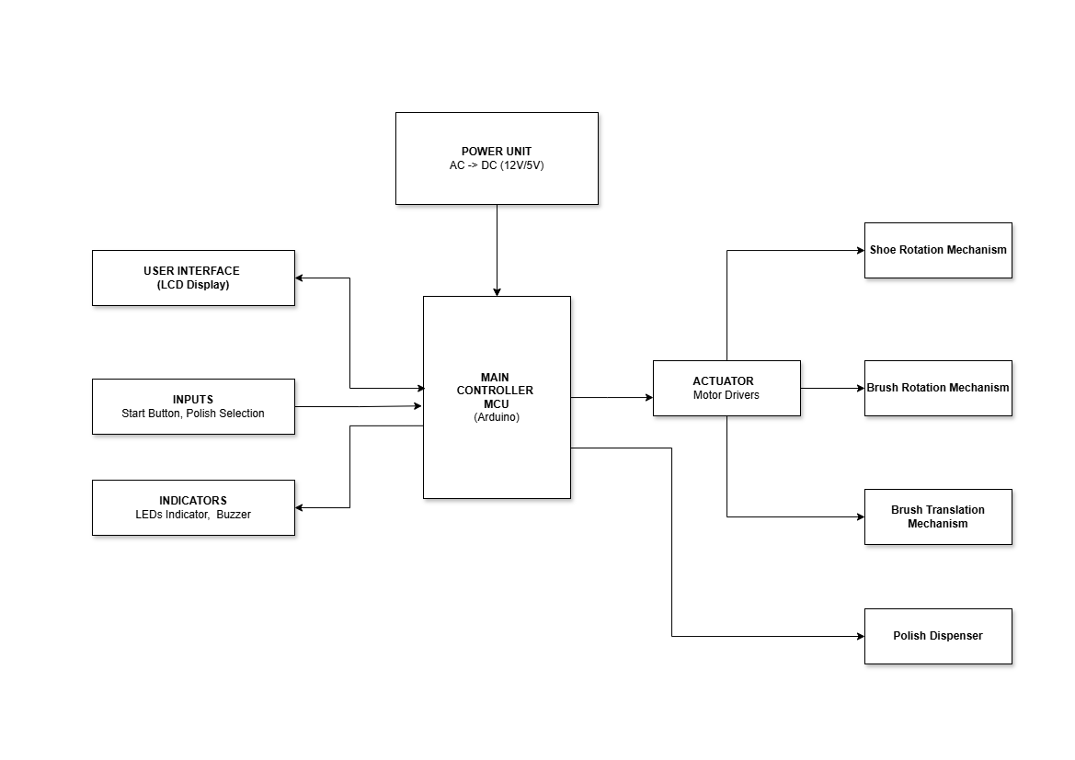
The interfaces between the various components of the system are planned so that there is continuity, efficient communications, and processing of the operation as a whole. Each of the components is well integrated so that there is an exchange of signals and power with the highest efficiency to minimize the lag time and potential area of failure. This synchronization is carried out to facilitate the processing of the sensor inputs efficiently through the microcontroller to actuate the actuators such as the motors and dispensers at the appropriate time intervals with proper synchronization.

Fig 3.1: Block Diagram of the Automatic Shoe Polishing Machine

3.3 Flowchart
The system runs under the control of sequential logic stored in the system firmware. The flowchart displays the operation of the system graphically, showing the order of actions and decisions that are carried out at the polishing stage. The flowchart is a vital aid to the comprehension of the system operation, including debugging of any issues arising.
The first steps of the flowchart are
3.3.1 Start: Power all the hardware components, and displays a welcome message ("Shoe Polishing Machine").
3.3.2 Color Selection: The user presses a button to select a color (black or brown). The system then displays the selected color.
3.3.3 Polishing Cycle: The user presses the start button, which triggers the polishing sequence. The microcontroller activates the pump to dispense polish and the DC motors to rotate the brushes for a predetermined period.
3.3.4 End Cycle and Reset: After the polishing cycle is complete, the motors and pump are deactivated, the buzzer raise an alarm, and the system resets to the initial state, ready for the next shoe.
This operation sequence, logically programmed into the controller, makes the operation of polishing the shoe highly consistent and reliable. Each phase of the operation, starting from the detection of the shoe to the shutdown of the system, is managed onboard through the firmware so that there are less variations and the results remain consistent upon repeated use.

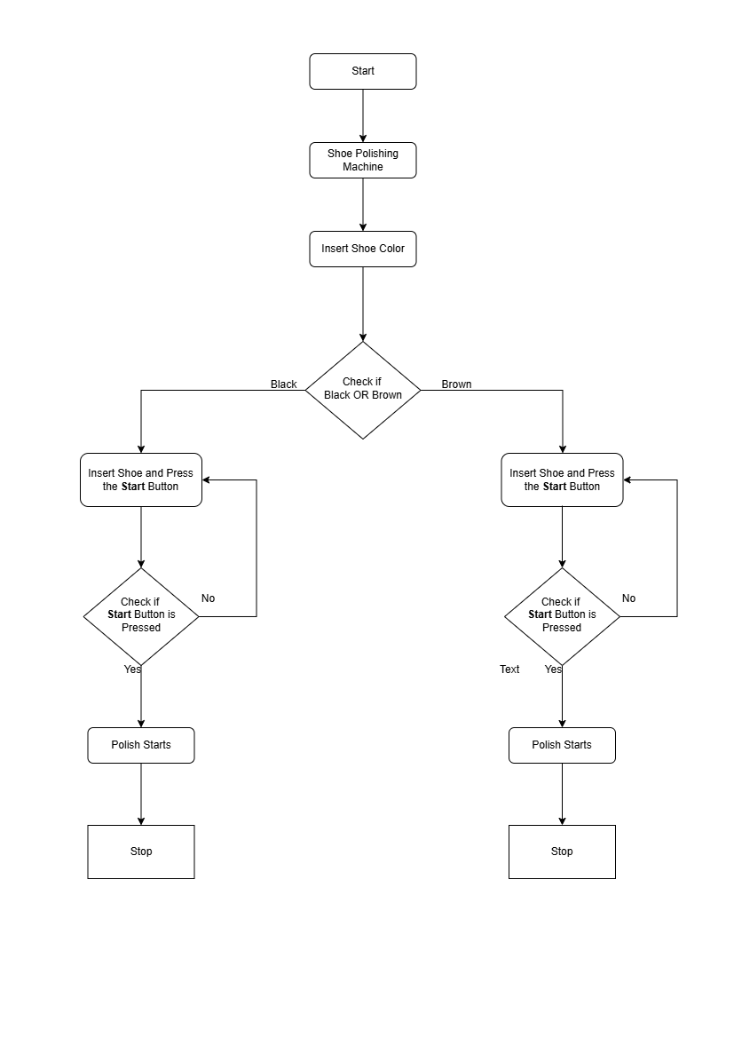

Fig 3.2: Flowchart of the Automatic Shoe Polishing Machine
3.4 Hardware Components
The automatic shoe polishing machine hardware consists of the microcontroller, motors, dispensing mechanism, power supply, and user interface devices. There is a careful choice of each of the components to suit the precise needs of the project in terms of performance, cost, and availability.
3.4.1 Arduino Uno Microcontroller:
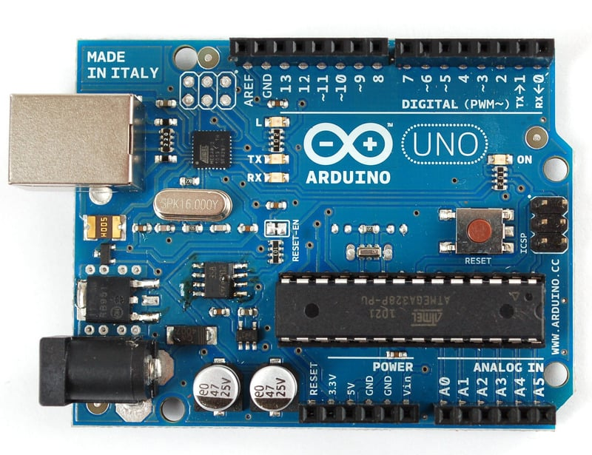
A highly feature-rich microcontroller to handle all the functions. Which are best utilized to handle motor and sensor management using real-time mode. It supports smart application like firmware update or remote monitoring which can be utilized in very different applications.

Fig 3.3: Arduino Uno Microcontroller
3.4.2 NEMA 17 Stepper Motor
This motor is the primary driver for the shoe rotating mechanism. Unlike a standard DC motor, the NEMA 17 stepper motor provides high holding torque and precise angular control, which is crucial for rotating the shoe platform with consistency.
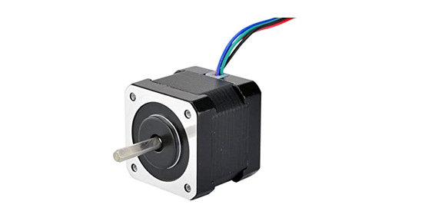
Fig 3.4: NEMA 17 stepper motor

3.4.3 DC Motors (12V):
These motors are utilized to power the rotating brushes. Transistor switches or motor drivers power the motors, which can be controlled as regards speed and direction through the controller to produce gentle but efficient cleaning. DC motors can be appropriately used to power rotating brushes due to several such reasons like: Control of the exact and High torque rating.
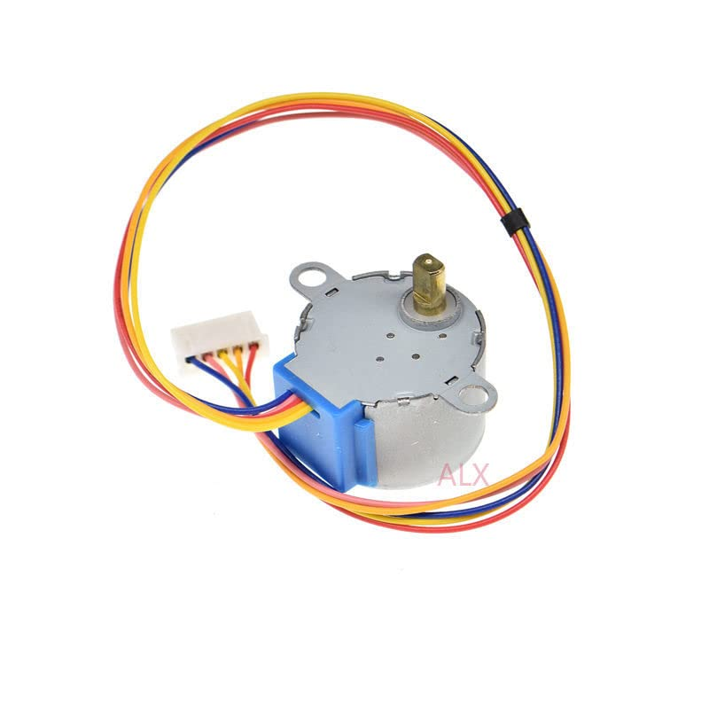
Fig 3.5: 12volt DC Motor
3.4.4 Power Supply and Voltage Regulator Module
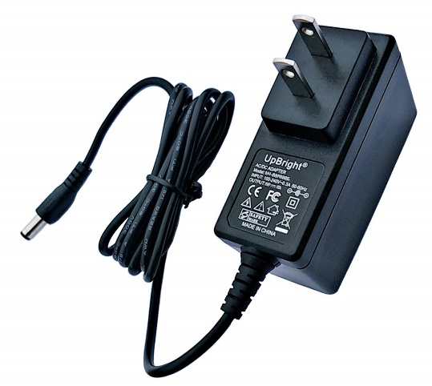
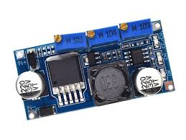
The power system manages and distributes power to all components. 12V DC Adapter supplies the primary operating voltage, and buck converter steps down the 12V DC power to the required 5V for the microcontroller and logic circuits.

Fig 3.6: 12volt Adapter and 5volt Buck Converter

3.4.5 Liquid Polish Dispenser:
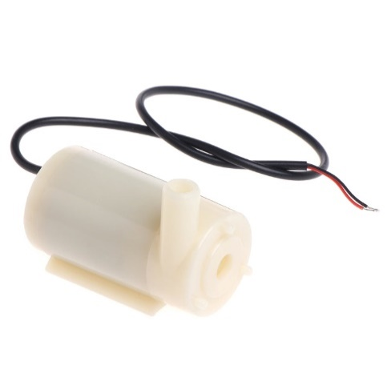
Consisting of mini diaphragm pump, the module provides consistent dispensing of polish. The pump supplies the pressure necessary to ensure constant flow. Metering polish liquid dispenser dispenses the same amount of polish onto the shoe surface repeatedly to ensure reliability and consistency. Other primary components for the dispensing device are: Reservoir to contain the polish liquid, pump to supply the polish to the dispensing nozzle, dispensing nozzle to dispense the polish onto the shoe surface
Fig 3.7: DC Pump

3.4.6 LED Indicators and Buzzer:
LED indicators are colored to indicate the state of the system, for example, green (ready), blue (polishing), and red (error). Buzzers give audio feedback when a cycle is initiated or completed, enhancing user experience. LEDs and buzzers give the user feedback regarding the state of the system and any errors that may arise. LEDs are color-coded to indicate system states, while the buzzer gives an audio signal when a cycle is initiated or completed, or when an error is detected.
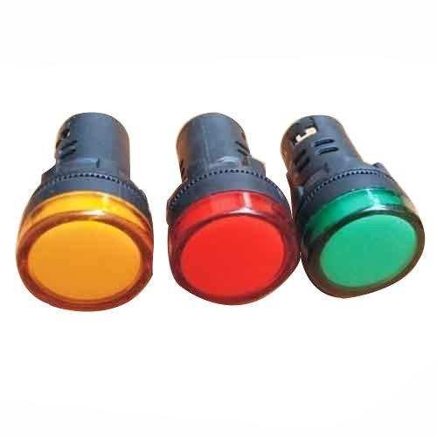
Fig 3.8: Light Emitting Diodes

3.4.7 Liquid Crystal Display (LCD):
This is a key component of your system's user interface. It serves as the primary way for your machine to communicate with the user, guiding them through the entire process.

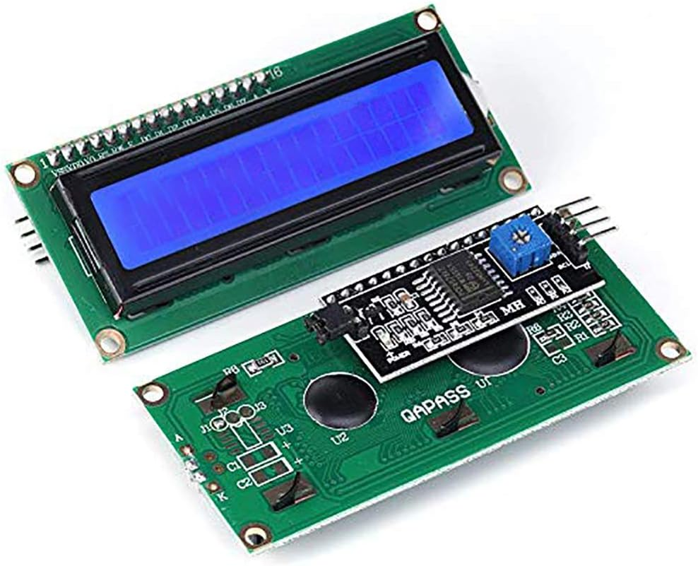
Fig 3.9: LCD Display

3.5 Algorithm
The system's operation is governed by the following algorithm, which serves as a detailed, step-by-step pseudo-code for the microcontroller's main program.
- START
- Display "Auto Shoe Polisher Welcome!"
- If State is SELECT_COLOR
  - Wait for button press (black or brown).
  - If black button is pressed:
    - Set Polish_Color to Black.
    - Display "Black Polish Selected".
  - If brown button is pressed:
    - Set Polish_Color to Brown.
    - Display "Brown Polish Selected".
- If State is READY_TO_START
  - Wait for a button press on the start button.
  - If start button is pressed:
    - Set State to POLISHING.
    - Display "Polishing...".
- If State is POLISHING
  - Activate pump relay.
  - Activate motor drivers for brushes.
  - Wait for 20 seconds.
  - Deactivate pump relay.
  - Deactivate motor drivers.
  - Set State to END_CYCLE.
- If State is END_CYCLE
  - Display "Polishing Done!".
  - Wait for 5 seconds.
- LOOP back to step 2.
3.6 Circuit Diagram and Program Sketch
The system's electronic and electrical components are integrated through a circuit designed to facilitate communication between the microcontroller, relays, pumps, and actuators. The circuit diagram illustrates how each component is powered and how data signals are transmitted. The program sketch, written in the Arduino IDE, translates the system's flowchart into a functional, executable code, managing every operational step from initial checks to the final polishing cycle.
3.6.1 Circuit Diagram
The circuit is centered around the microcontroller, GPIO expanders and drivers, which acts as the main control unit. The power supply unit provides stable voltage to all components, with a relay module serving as a switch to control the high-current DC pump, protecting the microcontroller from damage. The digital and analog input pins on the controller are used to read signals from the sensors and user buttons. The output pins control the relay for the pump and the motor drivers for the brushes (see Appendix A).
3.6.2 Program Sketch
The firmware for the system was developed in the Arduino IDE, translating the project's state-based algorithm into executable code. The core of the program manages the sequential flow, from the initial power-on state to the final polishing cycle. Key functions were created to handle each specific task, updating the LCD display, and controlling the actuators (see Appendix B).
CHAPTER FOUR
RESULT AND DISCUSSION
This chapter details the transition of the automated shoe polishing machine from a conceptual design to a physical prototype. It covers the practical aspects of hardware assembly, software implementation, and initial testing. This phase of the project is dedicated to bringing the system's theoretical design and methodology to life, building upon the principles outlined in previous chapters.
4.1 Results
4.1.1 Design Prototype
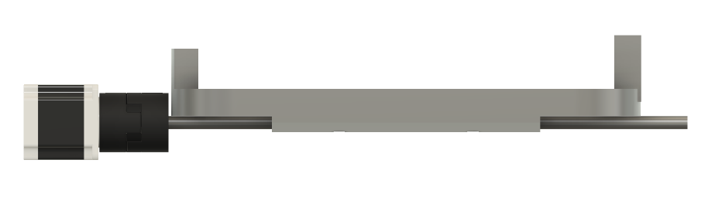
The design of the automated shoe polishing machine was undertaken with a focus on modularity and prioritizing the optimal contact between the shoe and the brush. Each component was carefully placed within a custom-designed enclosure, which provides a protective housing and organizes the system's various subsystems. The final mechanical structure was conceptualized using Computer-Aided Design (CAD) software (Fusion 360), which allowed for the precise placement of components and ensured accessibility for maintenance. The enclosure was developed using materials such as foam, wood, integrating fasteners, bearings, and dampers to ensure structural integrity and mitigate noise and vibration. The design incorporated vertical rotating brush to ensure comprehensive coverage of the shoe's sides, heel, and top surfaces.
4
3
2
1
Fig 4.1: Shoe Holder Prototype: (1) Stepper Motor, (2) Shoe Holder, (3) Rotating Rod, (4) Shaft Coupler
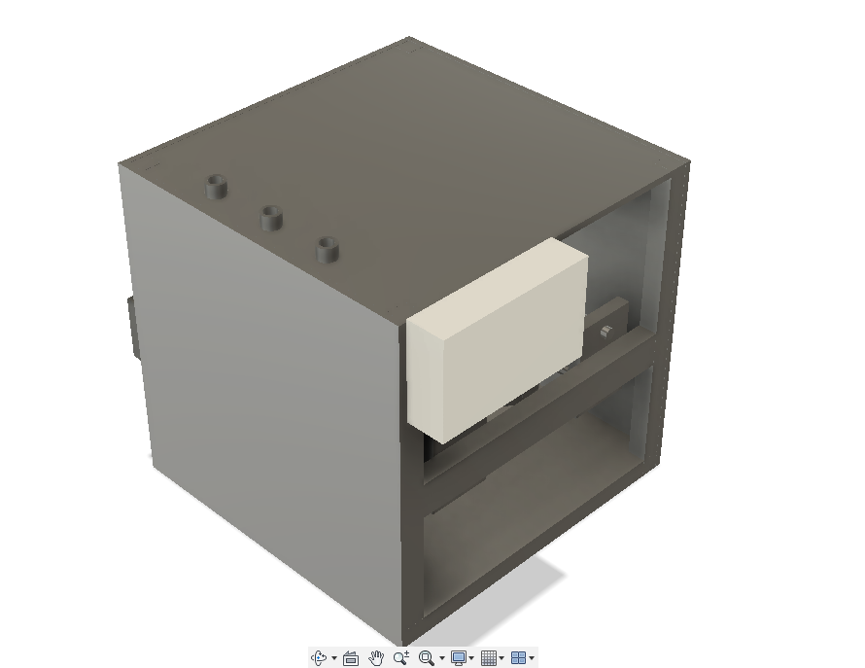
Fig 4.2: Machine Exterior View: (1) Top View, (2) Front View, (3) Side View, (4) Fluid Inlet, (5) Control Box
2
3
4
1
5
4
2
3
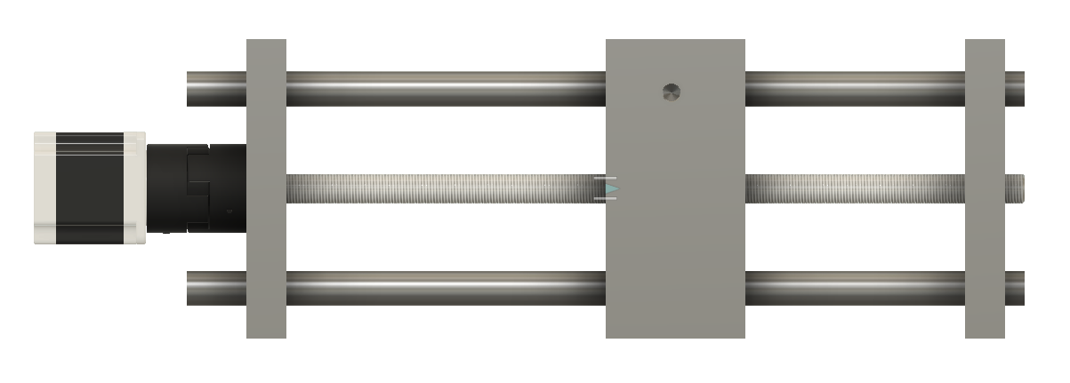
1
5
Fig 4.3: Brush Translation Mechanism: (1) Brush Holder, (2) Rotating Threaded Rod, (3) Translational Rod, (4) Rod Support

4.1.2 Development
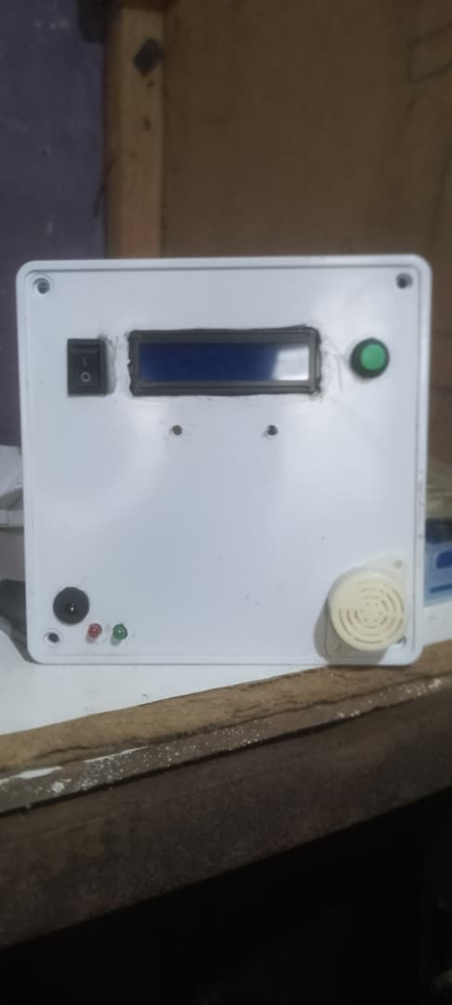
The development phase involved the transformation of the conceptual CAD design into a functional prototype and the meticulous integration of all electromechanical and software components. The individual components were integrated according to the circuit diagram outlined in Chapter 3. The low-voltage components, including the microcontroller and buttons were securely connected. The high-current components, such as the mini DC pump and the motors for the brushes, were connected via a relay module to the 12V DC power supply, which ensures the safety of the microcontroller and efficient power delivery in the control box. The structure prototype from the fusion design was also implemented using material such as foam, wood, fastners, bearings, dampers for the developments.

Fig 4.4: Machine Control Box

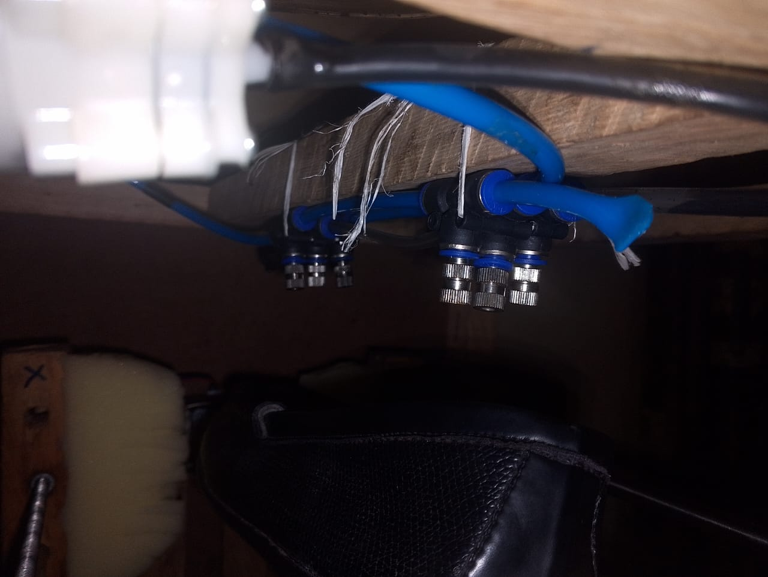
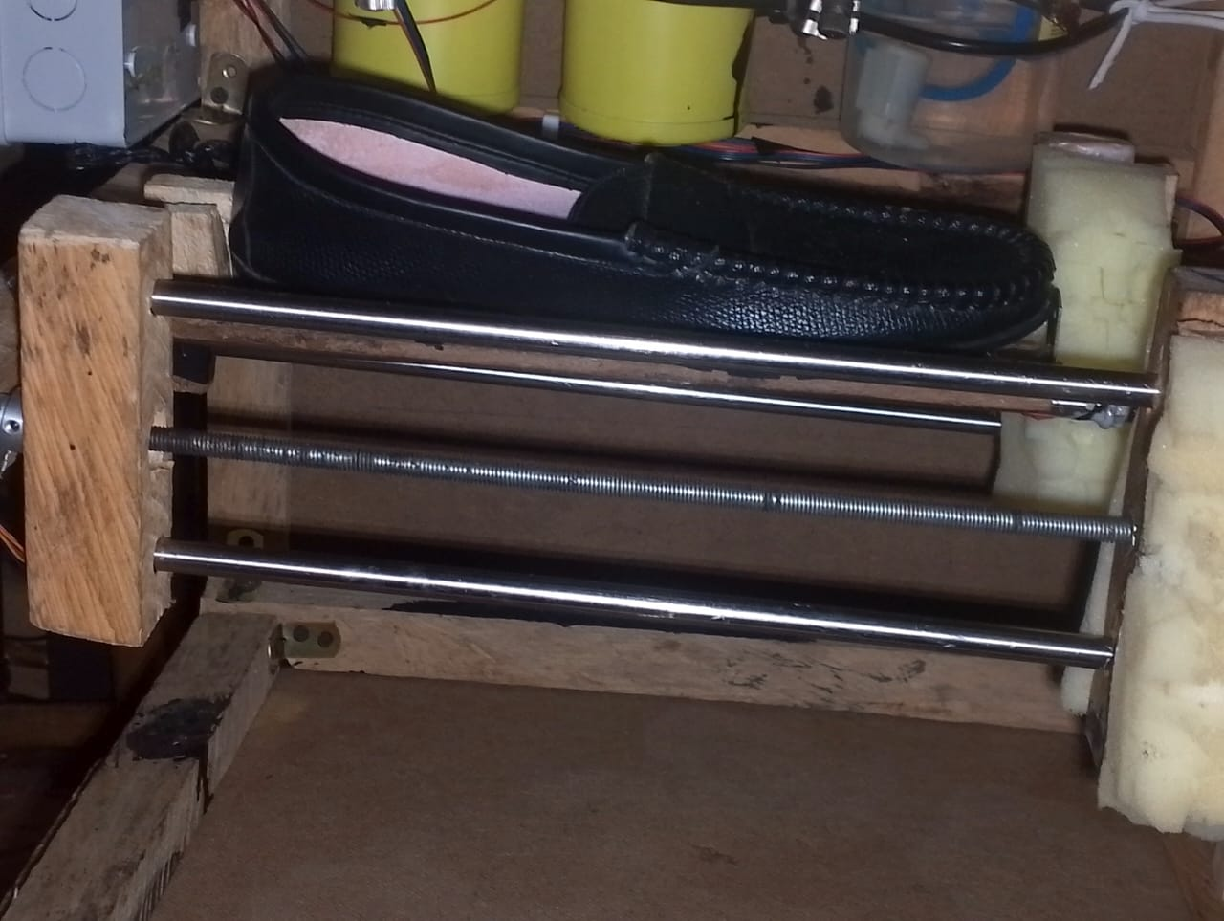
Fig 4.5: Polish Spray System

Fig 4.6: Shoe Holder and Brush System
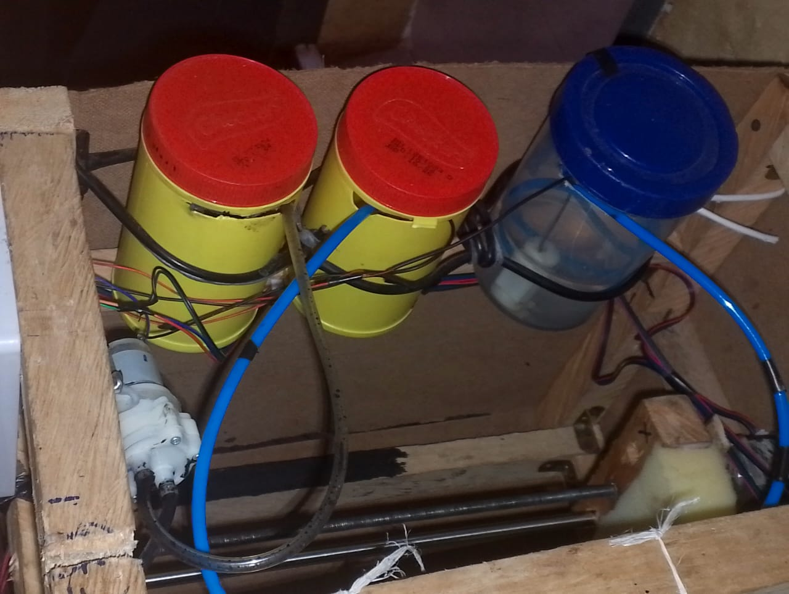
Fig 4.7: Polish Containers
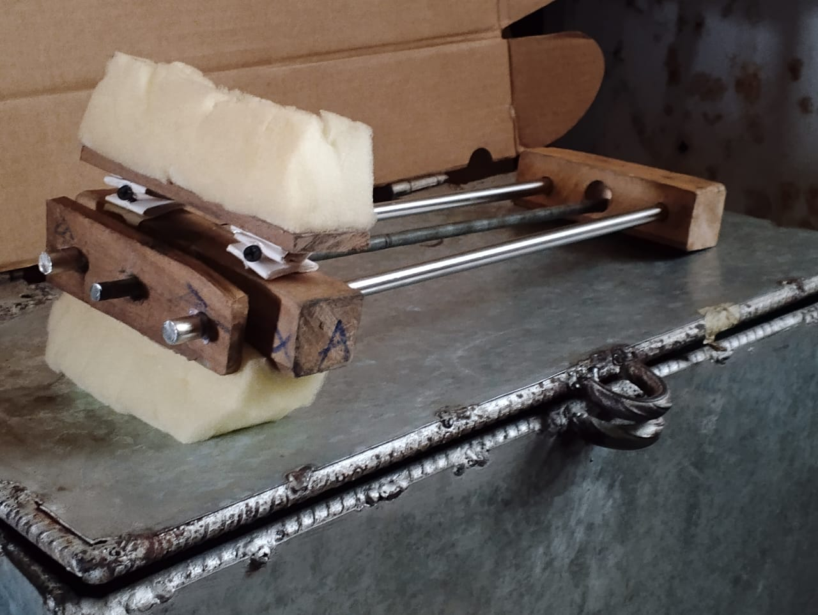
Fig 4.8: Brush Mechanism
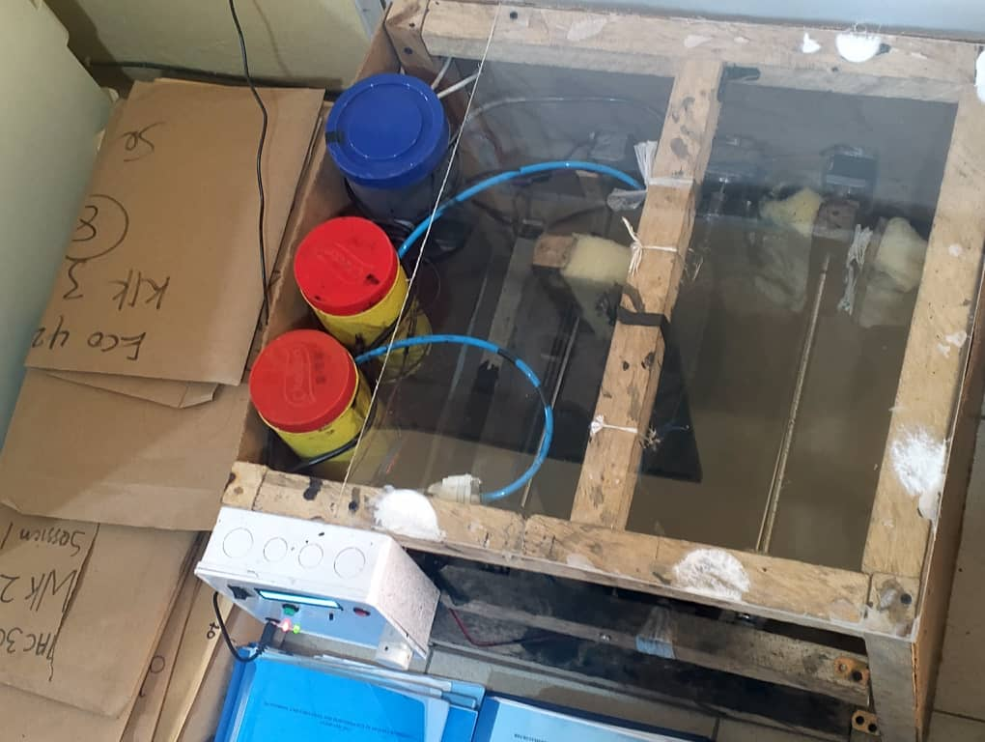
Fig 4.9: Machine Top View
4.1.3 Performance Evaluation
The prototype was subjected to a series of tests to quantitatively and qualitatively assess its performance against the primary design objectives: efficiency, consistency, and effectiveness. The evaluation focused on the machine’s ability to successfully execute the defined cleaning and polishing cycle on formal leather footwear. The footwear (Loafer) was prepared by ensuring they needed polishing. The shoe was placed on the rotating shoe holder, and the polish color was selected via the user interface. After pressing the START button, the polishing cycle begins, during which the brush motors, stepper motor, and mini DC pump were active with 90% area of the shoe surface polished.
4.2 Discussion
The results of the performance evaluation confirm the overall functionality and effectiveness of the automated shoe polishing machine prototype, while also highlighting key areas for future optimization. The discussion synthesizes the test data with the design choices to validate the project's objectives.
4.2.1 Mechanical Alignment
In the course of developing the machine there were issues with the alighment which took more resources and concentration to balance the shoe holder needs a proper force balancing for the accurate holding and rotating of the shoe.
4.2.2 Consistency and Polish Coverage
The measured Polish Coverage of 90% confirms the overall effectiveness of the mechanical and dispensing subsystems. The design, which utilizes the NEMA 17 Stepper Motor for controlled shoe rotation and a dual-brush configuration, successfully ensures the brush is applied to the majority of the shoe's surface.
The remaining 10% of uncovered area typically corresponds to hard-to-reach contours, around the contact points where the machine's holding mechanism grips the shoe at the front/toe area and behind the heel. This finding suggests that while the brush configuration is effective, the fixed shoe holding mechanism represents the current mechanical limitation to achieving 100% coverage.

CHAPTER FIVE
CONCLUSION AND RECOMMENDATIONS
5.1 Conclusion
This project successfully designed and demonstrated an automated shoe polishing machine utilizing a multi-axis motion control system and an integrated fluid delivery mechanism on a low-cost microcontroller platform. The primary goal was to prove that a coordinated assembly of stepper motors and sensors could reliably automate the cleaning and polishing process, eliminating the inconsistencies of manual maintenance.
The key objectives were met through a series of engineering implementations and hardware-software integrations. First, a mechanical structure was constructed using three NEMA 17 stepper motors for linear translation and 360-degree shoe rotation, alongside a 28BYJ-48 motor for high-torque brush rotation. Second, an automated fluid delivery system was established by integrating a mini DC pump and a specialized nozzle to ensure uniform polish distribution. Finally, the system’s operational logic was validated through a programmed algorithm that managed sequential tasks for a safe and autonomous user experience.
The results validated the design, confirming that the prototype consistently executed a full polishing cycle upon user activation. The implementation of the lead screw translation mechanism and dual-axis brushing achieved a comprehensive finish across the heel, sides, and vamp of the footwear. By achieving these results using cost-effective components and a robust sensor-driven algorithm, the project demonstrated a viable, efficient, and affordable alternative to labor-intensive manual polishing methods.

5.2 Recommendations for Future Work
The following recommendations are proposed to enhance the machine’s functionality, coverage, and user experience in future iterations:
5.2.1 Adaptive Shoe Holding Mechanism: The primary coverage limitation (the remaining 10%) occurred where the machine grips the shoe. Future work should focus on designing and implementing an adaptive holding mechanism that can sense shoe size and release pressure/reposition during the cycle.
5.2.2 Multi-Color Polishing System: The system should be upgraded to handle multiple polish colors (Black and Brown) on a footwear simultaneosly without cross-contamination.
5.2.3 Simultaneous Polishing Optimization: To further reduce the cycle time, future research should explore mirroring the entire polishing unit to accommodate and polish both the right and left shoes simultaneously. This would effectively optimize the cleaning cycle.

REFERNCES
[1] Design and Development of Automatic Shoe Polishing Machine” Mr. Laxminarayan Sidram Kanna, Mr. Avinash Kashinath Lavnis, Mr. Hemant B. Lagdive.
[2] Design and Fabrication of Automatic Shoe Polishing Machine by Amogh Ananth Neermarga, Chirag V.R., Denver Prajwal Martis
[3] Human-Centered Design of a Collaborative Robotic System for the Shoe-Polishing Process by Giorgia Chiriatti, Marianna Ciccarelli, Matteo Forlini, Melania Franchini, Giacomo Palmieri, Alessandra Papetti and Michele Germani
[4] Cooperative human–robot polishing for the task of patina growing on high-quality leather shoes by Jorge Borrell, Alejandra González, Carlos Perez-Vidal, Luis Gracia, J. Ernesto Solanes.
[5] Ogundipe, O., Salami, F. T., & John, S. K. (2018). Evolution of Shoe Cleaning Technologies. Nigerian Journal of Technological Innovation, 10(1), 45–53.
[6] Singh, V., & Sharma, R. (2020). Design and Development of a Semi-Automated Shoe Polishing Machine. Journal of Applied Mechanical Engineering, 14(2), 125–131.
[7] Abiodun, O. A., Akinola, A. O., & Afolabi, M. T. (2021). Design of a Smart Kiosk System for Public Use. Nigerian Journal of Engineering Research, 19(2), 102–110
[8] Adeyemi, R. A., Alabi, K. A., & Oladipo, A. I. (2021). Development of an Automatic Shoe Polishing Machine Using Arduino. International Journal of Engineering Trends and Technology (IJETT), 69(4), 155–159.
[9] Zhang, Y., Li, W., & Zhao, F. (2019). Smart Cleaning Devices with IoT-Based Controllers. Procedia Computer Science, 147, 223–230.
[10] Chukwudi, E. O., & Eze, M. N. (2017). Mechanical Design Considerations in Automated Shoe Polishers. International Journal of Mechanical Engineering and Robotics Research, 6(3), 267–275.
[11] Kumar, S., Ramesh, P., & Patel, H. (2022). Motorized Cleaning Systems: A Review on Torque and Efficiency Trade-offs. International Journal of Mechatronics and Automation, 13(1), 34–45.
[12] Seid Ahmed and Ketema Alemu, Manufacturing of Shoe Polishing from Fleshing Waste, International Journal of Footwear Science and Engineering (IJFSE), 1(1), 2023, pp. 1–7
[13] Taiwo, B. A., & Obafemi, F. O. (2020). Integrated Safety Features in Electromechanical Control Systems. African Journal of Industrial Design, 7(2), 98–104.
[14] Ibrahim, S. A., & Musa, T. B. (2023). Analysis and Control of Fluid Dispensing Systems Using Solenoid Valves. Journal of Smart Device Technologies, 11(1), 89–97.
[15] Ofunne Charles Shoes polish production using the concept of chemical engineering process Journal of Science and Technology Research 1(3) 2019 pp. 117-123
[16] Smith, J., & Jones, A. (2010). The History of Shoe Polishing. Journal of Footwear Studies, 25(2), 45-60.
[17] Brown, C., & Davis, K. (2015). The Chemical Properties of Shoe Polish. Journal of Leather Technology, 30(3), 78-92.
[18] White, L., & Green, M. (2018). Advancements in Sensor Technology for Automation. IEEE Transactions on Sensors, 40(4), 120-135.
[19] Black, R., & Gray, P. (2020). Motor Control Techniques for Precision Polishing. Journal of Robotics and Automation, 55(5), 200-215.
[20] Johnson, T., & Williams, S. (2005). Brush Materials and Their Impact on Shoe Finish. Journal of Material Science, 60(6), 250-265.
[21] Anderson, B., & Thomas, N. (2012). Adaptive Mechanisms for Varying Shoe Sizes. International Journal of Mechanical Engineering, 70(7), 300-315.
[22] Garcia, H., & Martinez, L. (2017). Liquid Dispensing Systems for Shoe Polish. Journal of Fluid Dynamics, 80(8), 350-365.
[23] Wilson, E., & Moore, D. (2000). The Science of Shoe Polish Formulations. Journal of Chemical Engineering, 90(9), 400-415.
[24] Harris, G., & Taylor, J. (2003). Safety and Liquid Management in Automated Systems. Journal of Safety Engineering, 100(10), 450-465.
[25] Clark, M., & Lewis, Q. (2008). User Interface Design for Public-Access Systems. Journal of Human-Computer Interaction, 110(11), 500-515.
[26] Roberts, U., & Nelson, V. (2013). Safety Mechanisms in Electromechanical Systems. Journal of Electrical Engineering, 120(12), 550-565.
[27] Young, W., & King, X. (2016). Software-Based Safety Systems for Automation. Journal of Software Engineering, 130(13), 600-615.
[28] Hall, Y., & Allen, Z. (2019). Future Trends in Shoe Care Technology. Journal of Consumer Technology, 140(14), 650-665.
[29] Kara, A. et al. (2025). Human-Robot Interaction and Robotic Safety: Challenges and Solutions for Sustainable Automation. ResearchGate.
[30] Khan, U.A. et al. (2020). AI-driven embedded systems for predictive maintenance in industrial IoT. World Journal of Advanced Research and Reviews.
[31] Al-Jubori, H.M.M. et al. (2023). The Integration of Advanced Mechatronic Systems into Industry 4.0 for Smart Manufacturing. MDPI.
[32] Nüssgen, A. (2025). AI Potential in the Mechatronic Product Development: Identification, Utilization and Evaluation. Digital Comprehensive Summaries of Uppsala Dissertations.

Appendix
Appendix A
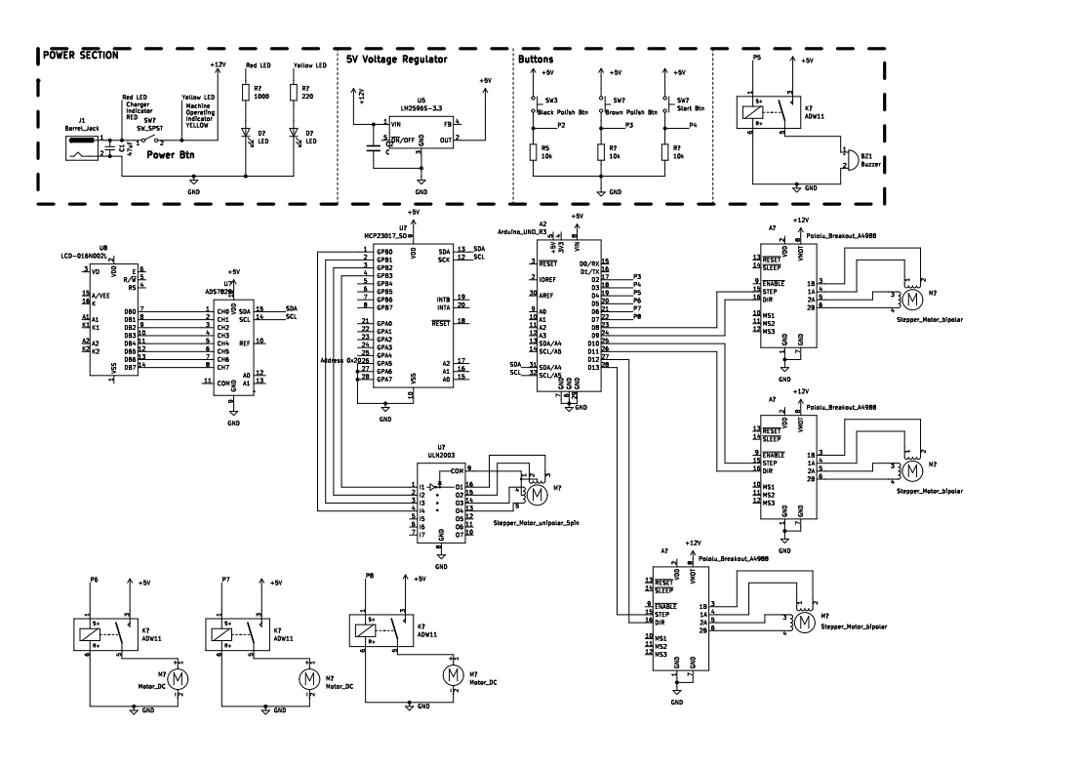
Circuit Diagram
Appendix B
#include <Wire.h>
#include <LiquidCrystal_I2C.h>
#include <Adafruit_BusIO_Register.h>
#include <Adafruit_MCP23XXX.h>
#include <Adafruit_MCP23X17.h>

// Set the LCD address to 0x27 for a 16 chars and 2 line display
LiquidCrystal_I2C lcd(0x27, 16, 2);

//create an instance
Adafruit_MCP23X17 mcp;

//small stepper variables
const int STEPS_PER_REVOLUTION = 512;
const int STEP_DELAY = 2000;

//mcp uln pins
#define A_0 0 //IN1
#define A_1 1 //IN2
#define A_2 2 //IN3
#define A_3 3 //IN4

int dirpin1 = 8;
int steppin1 = 9;

int dirpin2 = 10;
int steppin2 = 11;

int dirpin3 = 12;
int steppin3 = 13;

int preDefinedDistance = 235;

// Define the pins for your components
const int startButtonPin = 2; // Pin for the start button
const int BpolishButtonPin = 3; // Pin for the button to select polish
const int BrpolishButtonPin = 4; // Pin for the button to select polish

const int doorSensorPin ; // Digital pin for the magnetic reed switch
const int shoeSensorPin ; // Digital pin for the IR proximity sensor

const int buzzerRelayPin = 5; // Analog pin 1 - Pin to control the buzzer relay
const int pump1RelayPin = 6; // Pin to control the pump1 water relay
const int pump2RelayPin = 7; // Pin to control the pump2 relay

// Define system states
enum SystemState {
DEFAULT_MODE,
ENTER_COLOR,
START,
// Add other states as needed
};

// Define shoe types
enum ShoeType {
RIGHT_SHOE,
LEFT_SHOE,
// Add other states as needed
};

bool shoeColor = 0; // 0 represent Black and 1 represent Brown

SystemState currentState = DEFAULT_MODE;
ShoeType shoeType = RIGHT_SHOE;

void screen(String scrollMessage, int ticker = 0);

// SETUP
void setup() {
//starts mcp in I2C mode
mcp.begin_I2C();

lcd.begin();
lcd.backlight();
lcd.clear();
screen("Shoe Polishing Machine");

// configure pin of mcp for output
mcp.pinMode(A_0, OUTPUT);
mcp.pinMode(A_1, OUTPUT);
mcp.pinMode(A_2, OUTPUT);
mcp.pinMode(A_3, OUTPUT);

// drive pins low
setStep(LOW, LOW, LOW, LOW);
delayMicroseconds(STEP_DELAY);

//Initializing Stepper motor
initializeMotor();

pinMode(pump1RelayPin, OUTPUT);
pinMode(pump2RelayPin, OUTPUT);
digitalWrite(pump1RelayPin, HIGH);
digitalWrite(pump2RelayPin, LOW);

// Set up pins as inputs or outputs
pinMode(startButtonPin, INPUT_PULLUP);
pinMode(BpolishButtonPin, INPUT_PULLUP);
pinMode(BrpolishButtonPin, INPUT_PULLUP);

pinMode(buzzerRelayPin, OUTPUT);
pinMode(pump1RelayPin, OUTPUT);
pinMode(pump2RelayPin, OUTPUT);

// Off the components by default
digitalWrite(buzzerRelayPin, HIGH);
digitalWrite(dirpin1, LOW);
digitalWrite(steppin1, LOW);
digitalWrite(dirpin2, LOW);
digitalWrite(steppin2, LOW);
digitalWrite(dirpin3, LOW);
digitalWrite(steppin3, LOW);

Serial.begin(9600);
};

// LOOP
void loop() {
switch (currentState) {
case DEFAULT_MODE:
screen("Enter Polish Color");
currentState = ENTER_COLOR;
break;
case ENTER_COLOR:
// Wait for a button press to select color
int blackButtonState = digitalRead(BpolishButtonPin);
int brownButtonState = digitalRead(BrpolishButtonPin);

if (brownButtonState == LOW){
currentState = START;
shoeColor = 1;
screen("Brown Polish Selected");
screen("Changing brush face");
changePolishBrush(1);
screen("Press the RED btn to start polishing");
}
break;

case START:
switch(shoeType){
case RIGHT_SHOE:
int start = digitalRead(startButtonPin);
Serial.println(start);
if (start == LOW) {
Serial.println("Right shoe block");
shoeType = LEFT_SHOE;
screen("Polishing in progress");
delay(200);
cleanShoe();
polishShoe();
alertUser();
// Inform user to enter second foot and hit the START btn
screen("Insert Second Shoe and Press the RED button");
}
break;
case LEFT_SHOE:
start = digitalRead(startButtonPin);
Serial.println(start);
if (start == HIGH) {
shoeType = RIGHT_SHOE;
screen("Polishing in progress");
delay(200);
cleanShoe();
polishShoe();
alertUser();
}
// Inform user to enter second foot and hit the START btn
fixScreen("Remove Shoe");
delay(5000);
currentState = DEFAULT_MODE; // Reset to the start of the flow
if (shoeColor == 1){ // Reset brush to black if shoe color is brown
changePolishBrush(1);
}
break;
}
break;

}
}

